**Lawrence Page**

**Introduction**  
I was inspired by Lawrence Edward Page and so I have chosen to write about him, his achievements and why he is a personal inspiration. Larry Page is an American entrepreneur, visionary and software engineer. He is most widely known as a co-founder of Google Inc. along with Sergey Brin.

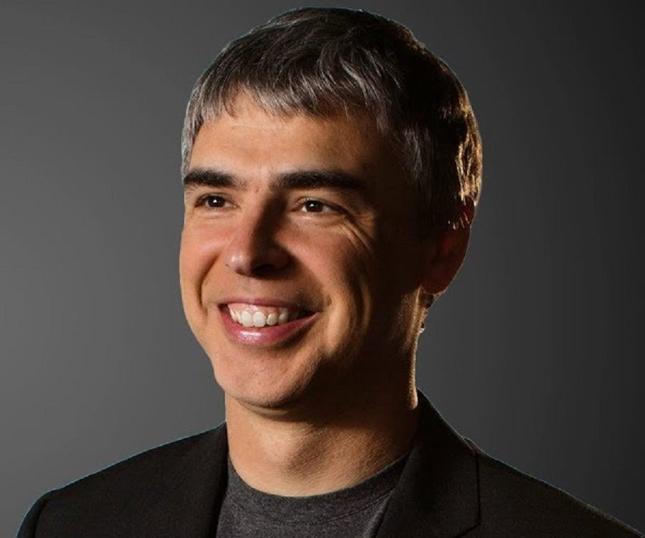

What began as an idea for a new type of search engine technology in Larry Page’s dorm room has grown into one of the largest tech companies to exist, Alphabet and has exploded into all aspects of the internet and irreversibly changed the world forever. Page is an inspiration to me because he has shown definitively that any idea, no matter how large or daunting can be made into reality through hard work, personal resolve and commitment to your vision.

**Childhood and Education:**  
Larry was born to Carl and Gloria Page on March 26, 1973. From an early age Page was exposed to the field of computer science through his parent’s influence as they were both involved in the field. His father being a professor of Computer Science in University of Michigan, holding a PhD. His mother was also a computer programming instructor. Page recalls from his youth that their family home "was usually a mess, with computers, science, and technology magazines and Popular Science magazines all over the place". Being an avid reader from a young age, Page steeped himself in the world of technology and computer science. He attributes his parents influence as the driving force which led him towards his passion in computer science. To foster his natural creativity and inventiveness, Page was enrolled in an educational Montessori centre.

“Anything you can imagine probably is doable, you just have to imagine it and work on it”- Larry Page

Page attended East Lansing High School graduating in 1991. When it came time to choose a path in college, Page undertook a bachelor’s degree in computer engineering at the University of Michigan following the lead of his parents. While at university, his creativity thrived it is noted that he built an inkjet printer out of Lego bricks. His innovative thinking and creativity were put to good use when he joined the 1993 "Maize & Blue" University of Michigan Solar Car team, which no doubt sparked his curiosity in the transport technologies. He proposed a plan to the university to replace the archaic school bus system with a “personal rapid transit system”, a driverless solution comparable to a monorail with individual coaches for each person. He displayed strong leadership qualities even as an undergraduate, serving as president of his fraternity, Beta Epsilon chapter of the Eta Kappa Nu.

Page graduated with honours from the University of Michigan in 1995 enrolling straight into a Computer Science PhD program in Stanford University. Page subsequently began his search for a dissertation theme. He settled on exploring the mathematical properties of the world wide web and specifically focussing on understanding its link structure as a huge graph. Page focused on studying the structure of websites and their links, classifying the nature and number of such back links as important and valuable data for that website.  
Page’s PhD studies are what led him to Sergey Brin, a fellow PhD student at Stanford University also pursuing Computer Science. Brin soon joined Page’s research project nicknamed, ‘BackRub’. Together, they developed BackRub to operate on Stanford’s server initially. It eventually took up too much bandwidth and was taken down. This was the first search engine Page had developed and it was the stepping-stone to something much bigger.

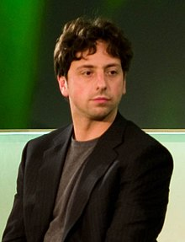

**The PageRank Algorithm**  
Page and Brin utilised the data collected by their BackRub’s web crawler to develop their PageRank algorithm which converted the data into an ordered list of importance of the back links. They realised the integration of this algorithm into a search engine could create a new type of search engine far superior than any others of its kind which had been developed. They began to convert Page’s dormitory room into a machine laboratory which they filled with the necessary equipment needed to continue their research project. Once filled, they moved on to convert Brin’s room into a programming laboratory where they developed and tested new iterations of their search engine. Together, Page and Brin produced a paper entitled, “The Anatomy of a Large-Scale Hypertextual Web Search Engine" in which they detailed their search engine and PageRank algorithm as an objective measure of a page’s importance based on an individual’s personal preferences and historic searches/queries. Soon thereafter, Page suspended his PhD studies at Stanford to pursue the development of his new search engine, which he named Google.

**Establishing Google**  
The name Google arose from a discussion between Page and another PhD student from Stanford, Sean Anderson. It is derived from the mathematical term, Googol denoting the number 1 followed by one hundred zeros. However, when Page was searching for the domain’s availability, he accidentally searched for Google.com which he ended up liking more. Hence, BackRub was renamed, and Google was born on the 15th of September 1997. Page and Brin acquired some limited funds from friends and family, along with a $100,000 investment from the co-founder of Sun Microsystems, Andy Bechtolsheim. They were able to afford equipment including servers and the rent of a garage in Menlo Park which became Google’s first office. Page and Brin then incorporated Google with Page as CEO and Brin as Google Inc’s president.



**The Early Days of Google**  
From a young age, Page had been fascinated by the famous inventors, Nikola Tesla who invented the alternating current electric system and Thomas Edison. Tesla died penniless and alone, living in a hotel. Page took this as a cautionary tale, that for an idea to be successful, one must be innovative and creative but must also focus on the business side of inventing as Edison had done so well. As Chief Executive Officer of Google Inc., Page was living out his childhood dreams of owning a business. However, Page has admitted his early management skills at Google Inc. did not match the brilliance of his vision and ideas. Page established a set of simple rules to help guide Google Inc. to its ambitious goals;

1. Do not delegate- do everything you can yourself to improve efficiency
2. Don’t get in the way unless you are adding value to it
3. Do not be a bureaucrat
4. Ideas over age- Ideas are more important than age or rank and each individual deserves respect
5. Never stop someone from doing something, help them find a better way to do it

Page’s management style became unsustainable as he fixated on improving Google’s search engine to reduce lag times. He believed that the faster a search engine returned results, the more popular it would be. It was a biproduct of this goal that Google’s famously sparse home screen was developed.

**Google’s Expansion- Page’s Lost Decade**  
In 2001, investors, Kleiner Perkins and Sequoia Capital agreed to invest $50 million into Google on the condition that Page stepped aside from the CEO position in order to allow for the introduction of an experienced management team which could lead Google into the future. Eric Schmidt assumed the CEO role and Page was appointed President of Products. Under Schmidt Google went through an IPO in 2004. Page still had a strong say in the direction of Google as he would give Schmidt the final go ahead in all new initiatives. In his time as President of Products, Page orchestrated an acquisition of Android for $50 million without the knowledge of Schmidt. It was Page’s vision to create handheld computers which would allow Google to be accessible anywhere. Page’s acquisition proved successful as by 2010, Android became the most popular mobile operating system.

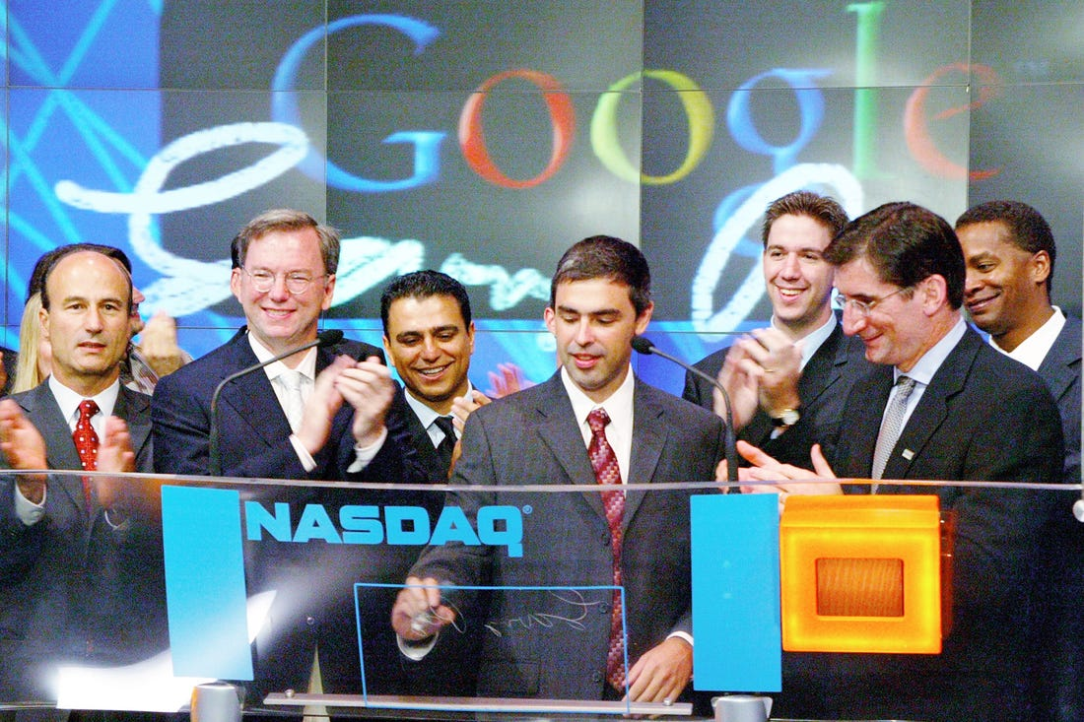

**At The Helm Again**  
In 2011 Schmidt announced that he was stepping down to assume the role of Executive Chairman at Google. After ten years, Page resumed his role as CEO of Google. In his time away from the CEO position, Page developed new management styles which contrasted greatly from those he imposed in his first tenure as CEO. Page Introduced two new goals;

1. Greater autonomy for executives overseeing the most important divisions
2. Increase levels of collaboration and communications within and between teams

Page wasted no time and began making drastic changes immediately. He shut down 70 products, features and services allowing greater focus on the remaining products. He instituted a new bolt-on acquisition strategy for the inorganic growth of Google. Page defined a new framework for assessing the potential acquisitions; Would you use it once or twice a day? And does it make your life easier? Page looked beyond profitability as he saw it as the way to maximise Google’s long-term value and continuously adding on value.



**Restructuring Google**  
In 2015, Page announced a huge restructuring of Google Inc into a series of companies and a holding parent company, Alphabet Inc. Page stepped aside as CEO handing the reigns to Sundar Pichai who remains the CEO of both Alphabet and Google.

**Conclusion**  
Larry Page is a huge inspiration to me. What began as a graduate project in Stanford with Sergey Brin has grown into one of the largest companies to ever exist. Despite starting from such humble beginnings of transforming their bedrooms into machine and programming laboratories, they have created something that has shaped the internet and changed the world forever. Page inspires me because he has shown that if you can imagine something, no matter how big or challenging it seems, if you commit yourself to it you can achieve anything. Larry Page set out to download the entire web and examine the links, and now Google receives over 3.5 billion searches daily.

“If you’re not doing some things that are crazy, then you’re doing the wrong things.” Larry Page

**Bibliography:**

Sergey and Page papers on ”The Anatomy of Large-Scale Hypertextual Web Search Engine”: 1 - Infolab.stanford.edu. (2017). The Anatomy of a Search Engine. [online] Available at: http://infolab.stanford.edu/~backrub/google.html [Accessed 15 Dec. 2017].

Details of Larry Pages Life Story 5 - Academy of Achievement. (2017). Larry Page - Academy of Achievement. [online] Available at: http://www.achievement.org/achiever/larry-page/ [Accessed 15 Dec. 2017]. 4 - D'Onfro, J. (2017).

Google CEO Larry Page says Elon Musk is 'kind of homeless' in Silicon Valley and sometimes asks if he can sleep over. [online] Business Insider. Available at: http://uk.businessinsider.com/elon-musk-sometimes-sleeps-over-at-larry-pages-house-2015- 5?r=US&IR=T [Accessed 15 Dec. 2017]. 6 - Famousinventors.org. (2017).

Larry Page | Biography, Inventions and Facts. [online] Available at: http://www.famousinventors.org/larry-page [Accessed 15 Dec. 2017]. 2 - Hartmans, A. (2017).

The fabulous life of Google cofounder and Alphabet CEO Larry Page. [online] Business Insider. Available at: http://uk.businessinsider.com/larry-page-alphabet-google-lifecareer-photos-2017-8?r=US&IR=T/#gloria-and-carl-page-had-their-second-son-lawrence-onmarch-26-1973-they-both-taught-computer-science-at-michigan-state-university-and-filledtheir-home-with-computers-and-tech-magazines-that-enthralled-larry-from-a-very-young-age1 [Accessed 15 Dec. 2017]. 1 - Infolab.stanford.edu. (2017).

The Anatomy of a Search Engine. [online] Available at: http://infolab.stanford.edu/~backrub/google.html [Accessed 15 Dec. 2017]. 3 - McAlone, N. (2017).

The true story behind Google's hilarious first name: BackRub. [online] Business Insider. Available at: http://uk.businessinsider.com/the-true-story-behind-googlesfirst-name-backrub-2015-10?r=US&IR=T [Accessed 15 Dec. 2017]